**RU_SIG_U_CMYK_K_S.tif Rutgers Translational Science**

**Research Pathology Services**

**PATHOLOGIST’S REPORT**

**Michael Goedken, DVM PhD Diplomate ACVP**

**michael.goedken@rutgers.edu**

**(848) 445-1434**

**PI:** Dr. Tony Kong (848-445-6368)

**Contact:** Anne Yuqing Yang, Phone=732-480-8158, yangampm@gmail.com

**Institution:** Pharm-Pharmaceutics

**Address:** 160 Frelinghuysen Road, Rm 228 Piscataway, NJ   08854-8020

**Report Date:** 20-MAR-18

**Report w/ added Excel file animal IDs, severity scoring and images:** 25-APR-18

**Project/Accession Number:** 18-1013

**Study Information:**

This study was designed to determine the effects of ursolic acid (UA, a pentacyclic triterpenoid found in berries and fruits) or sulphoraphone (SFN, an isothiocyanate found in cruciferase vegetables) in non-melanoma skin cancer carcinogenesis in a UV light model in female SKH-1 mice. Mice were exposed twice weekly with UVB light. UA or SFN treated mice topically received 2 μmol treatment in 200μL acetone. Mice were sacrificed 24 hours after their last treatment at 2, 15 and 25 weeks. The dorsal region of the skin was collected. Samples were fixed in fresh 3% paraformaldehyde for 24-48hrs at RT and then switched to 70% ethanol at RT (for 24hrs) or at 4C (greater than 24 hrs).

**Histology severity scores:**

Semiquantitative epidermal score criteria and resulting data table are as follows:

* Cell layers: 0≈2-3 cell layers, 1≈ 4-10 cell layers, 2≈10-20 cell layers, 3≈ 20+ layers
* DNA synthesis (mitotic figures, MF): 0= within range of normal, 1= minimal mitotic figures per high power field (HPF), 2= mild mitotic figures/HPF, 3= moderate to marked MFs/HPF, 4= severe numbers of MF/HPF
* Necrosis: 0= 0-5 necrotic cells/section, 1= 5-10 cells/section, 2= 10-20 cells/section, 3= 20+ cells/section
* Inflammation: 0= within range of background, 1= minimal, few foci, less than 10 cells, 2= mild 5 to 10 foci, less than 10 cells, 3 moderate= 10 to 20 foci, less than 10 cells, marked= 10 to 20 more than 10 cells
* Chromosomal abnormalities: 0=0/high power field (HPF), 1≈ 1-2/HPF, 2≈ 3-8/HPF, 3 ≈ 10 or more/HPF
* Papilloma: exophytic epithelial neoplasm with well-differentiated, uniform and proliferative epithelium with no basement membrane invasion and low mitotic index
* Carcinoma: epithelial neoplasm with variable differentiation, epithelial proliferation extending into the dermis with elevated mitotic index

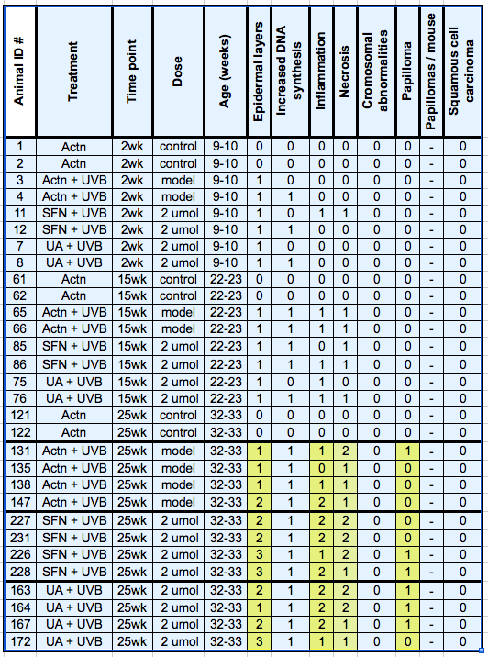

**Ancillary descriptions of skin tumor diagnoses and inflammation are below.**

Normal skin epidermis had several layers of desquamated keratin, several layers of uniform and well-differentiated epidermal cells. There was scant to no inflammation, degeneration or necrosis. Underlying tissue contained few inflammatory cells and included dermal extracellular matrix admixed with sebaceous glands, subcuticular adipose and/or pannicular fat.

Damaged skin without tumors had increased epidermal layers, DNA synthesis (mitotic figures), inflammation and/or necrosis. Epithelium was variably thickened by increased spinous keratinocytes, and contained more basal keratinocytes undergoing mitosis. The epidermis contained scattered swollen degenerate keratinocytes with swollen cytoplasm and necrotic keratinocytes with pyknotic nuclei and hypereosinophilic cellular debris. There were increased inflammatory cells including neutrophils, lymphocytes and macrophages in and/or below the epidermis.

Papilloma was an exophytic neoplasm composed of focal to multifocal proliferation of squamous epithelium arranged in ridges and folds with irregular thickening of the overlying keratin layer. Neoplastic epithelium was well differentiated and uniform in appearance with no evidence of basement membrane invasion. There was orderly differentiation, maturation and keratinization near the neoplasms’ surface. Erosion of the surface of the papilloma, scattered keratinocyte degeneration or necrosis and inflammation of the dermis and/or epidermis were sometimes present.

**Discussion:**

When multiple slides for a single animal were submitted, only one slide was scored giving preference to the slide with a tumor (a slide with no tumor was disregarded if one with a tumor was available). Some samples had undesirable, embedding-related artifact and/or did not always contain tumors when tumors were reported grossly.

Of the numerous criteria explored and evaluated, the single most valuable histology endpoint was the neoplastic diagnosis (normal skin, papilloma, carcinoma). Noteworthy criteria associated with lesser damage included hyperkeratosis (increased epidermal cell layers), mitotic figures (increased DNA synthesis), inflammation and necrosis. These four criteria are indications of the physiologic response of the skin responding to damage. Damaged cells (by UV light and/or treatment) may die and stimulate inflammation to remove them. Damage and loss of keratinocytes causes compensatory increased replacement with increased cell production by mitosis and thickening of the epidermis.

The Week 25 groups provided sufficient sample sizes for interpretation of skin damage/healing and neoplasia. All UVB treated groups had increased incidence of papilloma. One of four Acetone + UVB, two of four SFN + UVB and three of four UA + UVB had increased benign papilloma. Trending with the papilloma data were increased signs of cell damage including necrosis, inflammation and hyperkeratosis in the SFB + UVB and UA + UVB groups (compared to Acetone + UVB).

The investigator requested representative samples for all treatment groups. Due to inadequate sample size and/or quality, the pathologist determined representative samples were only available for the last time point. Despite this, images from each of the 12 treatment groups were provided and are shown below.

**Interpretation:**

Interpretation of histology incidence and severity score data when treatment groups have less than 3 cohorts are statistically not defendable and more or less an educated guess. At 2 and 15 weeks there was skin damage but no tumors. At 25 weeks, UVB treated mice had papilloma tumors in 25% of the acetone group, 50% of the SFN group and 75% of the UA group. Skin damage endpoints trended with tumor incidence (UA > SFN > Acetone). These results are not consistent with provided background literature and may have been caused by improper tissue sampling, inconsistent tissue embedding and/or sample size. Going forward, we would be happy to provide histopathology-related guidance before sample submission, ideally before study start.

Below images were taken at 200x magnification. Animal numbers for the respective images are mouse numbers 2, 4, 8, 12, 62, 65, 75, 8, 122, 131, 164, and 226.

**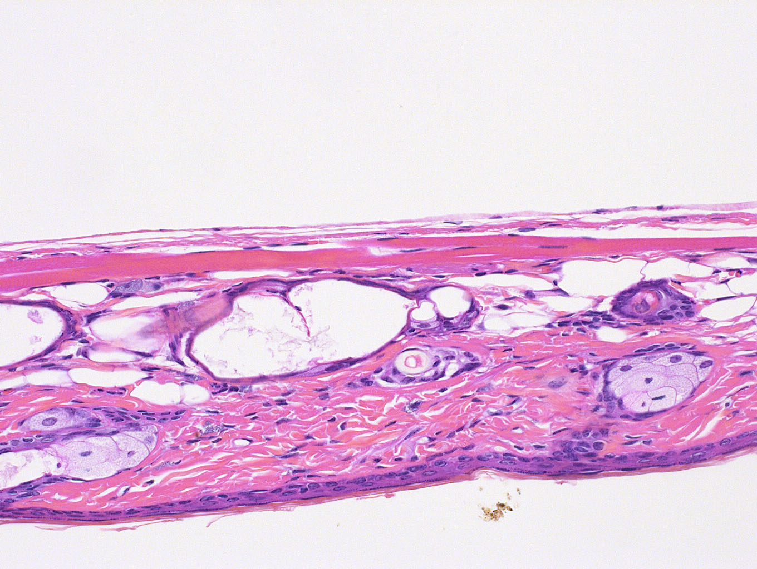**

Mouse # 2

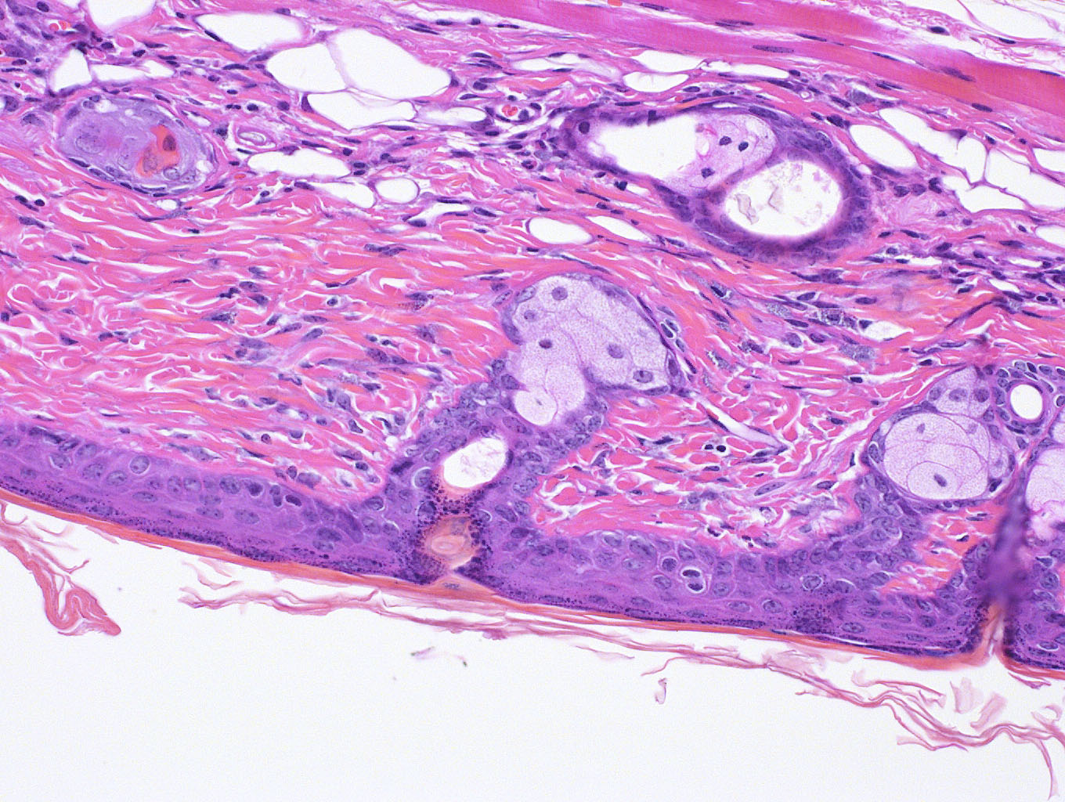

Mouse # 4

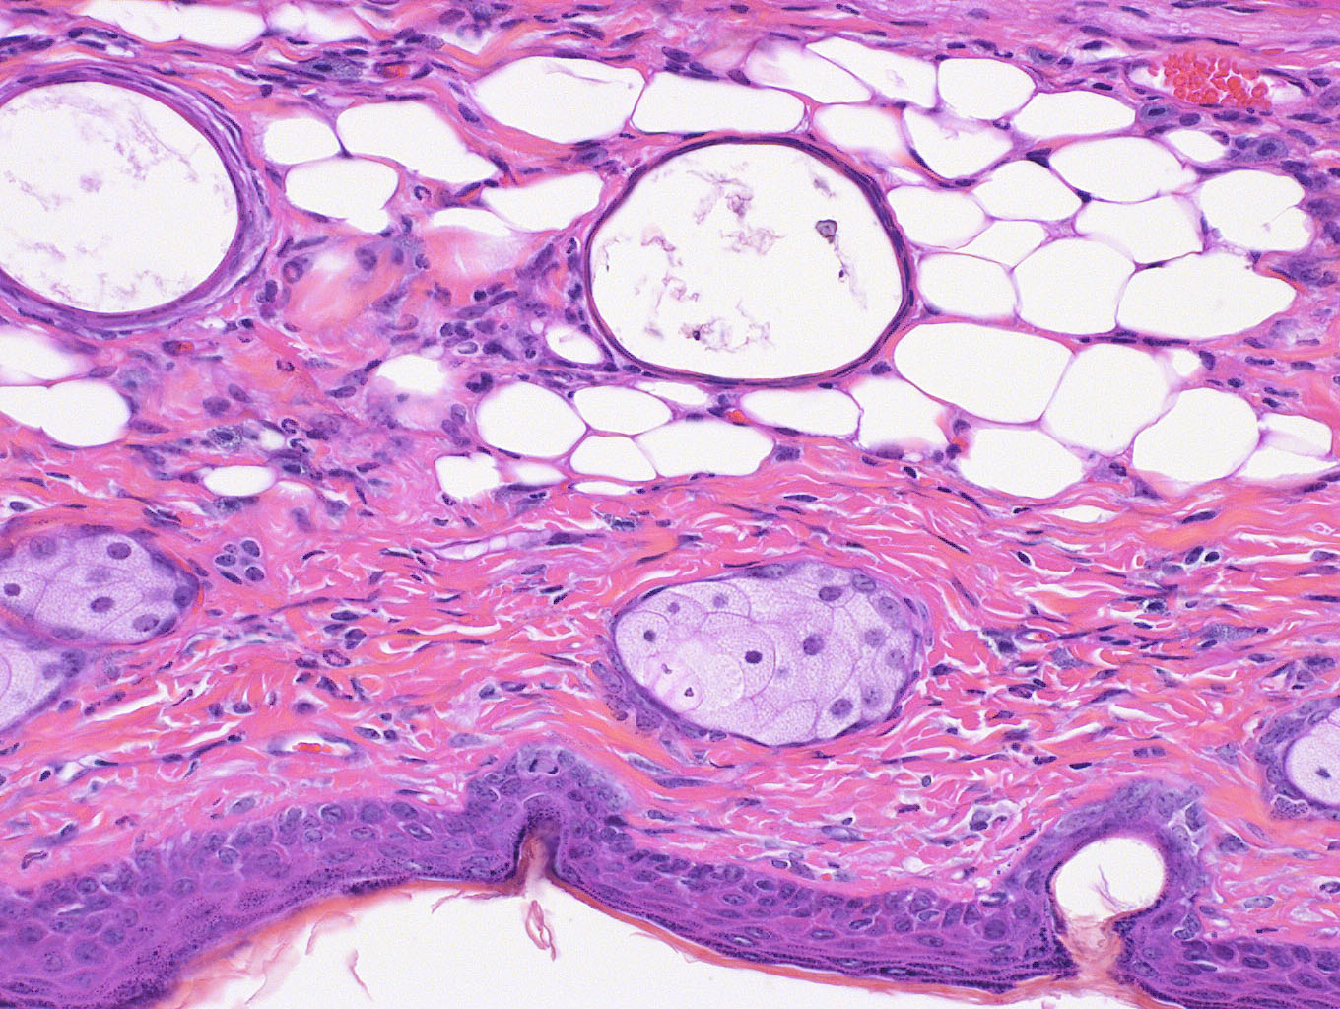

Mouse # 8

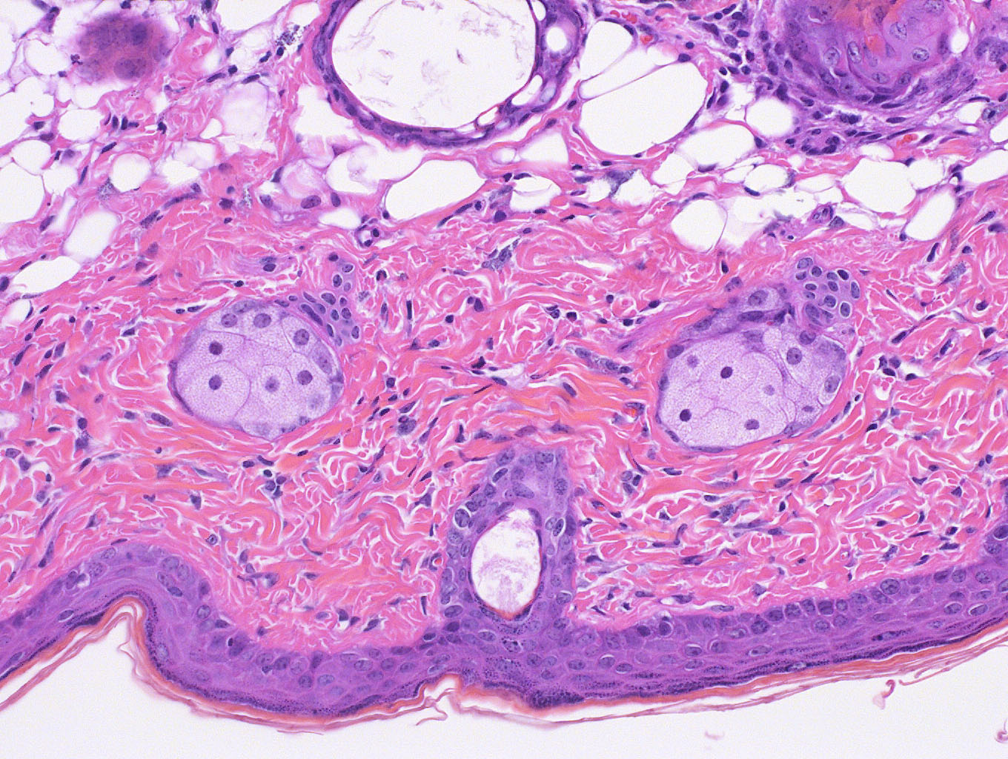

Mouse # 12

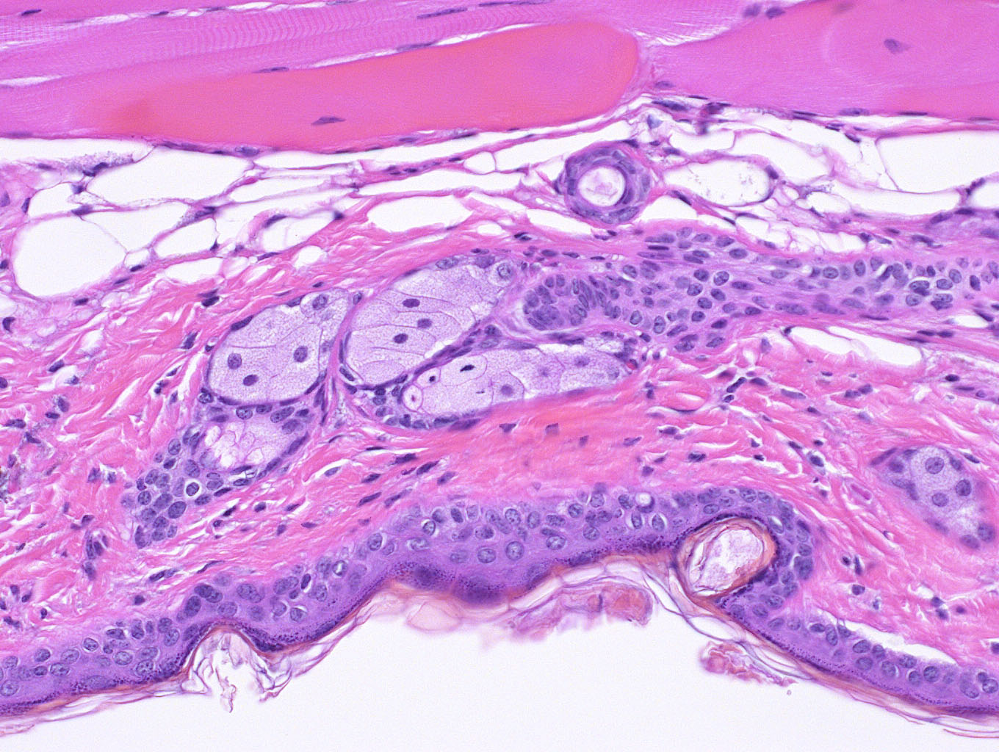

Mouse # 62

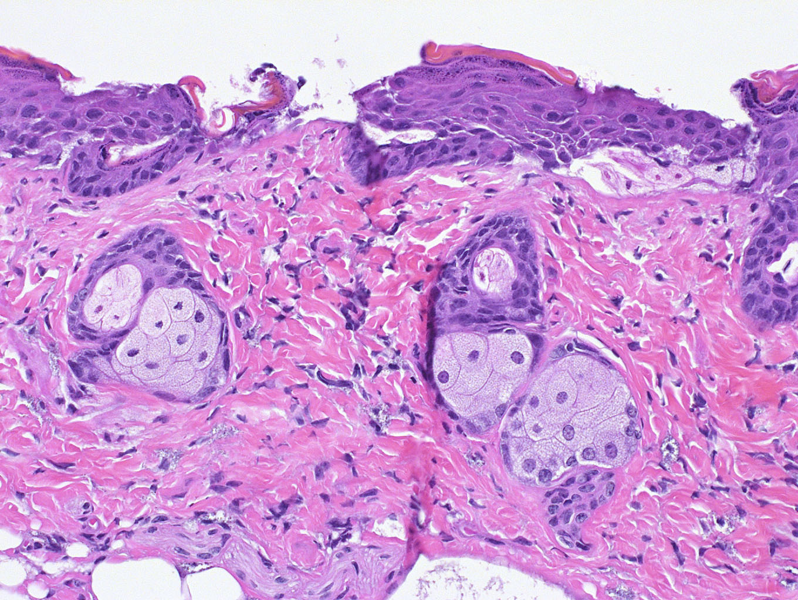

Mouse # 65

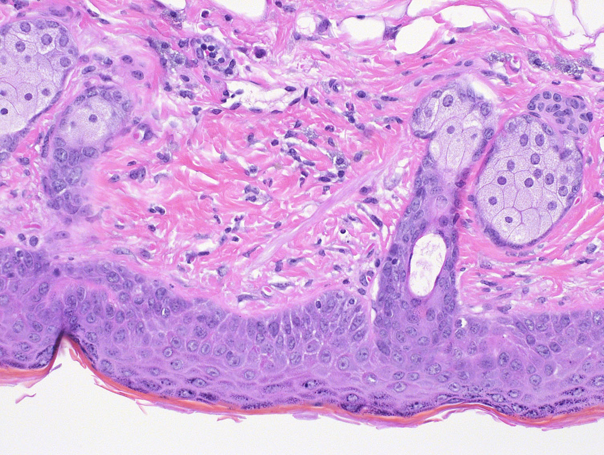

Mouse # 75

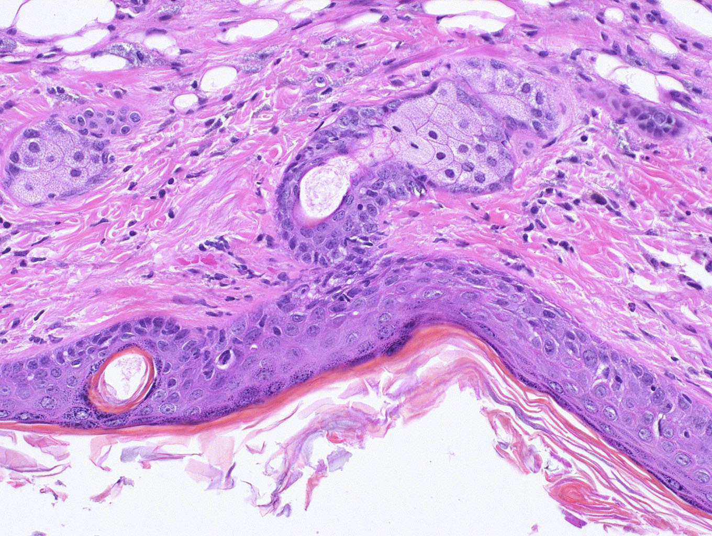

Mouse # 85 or 86

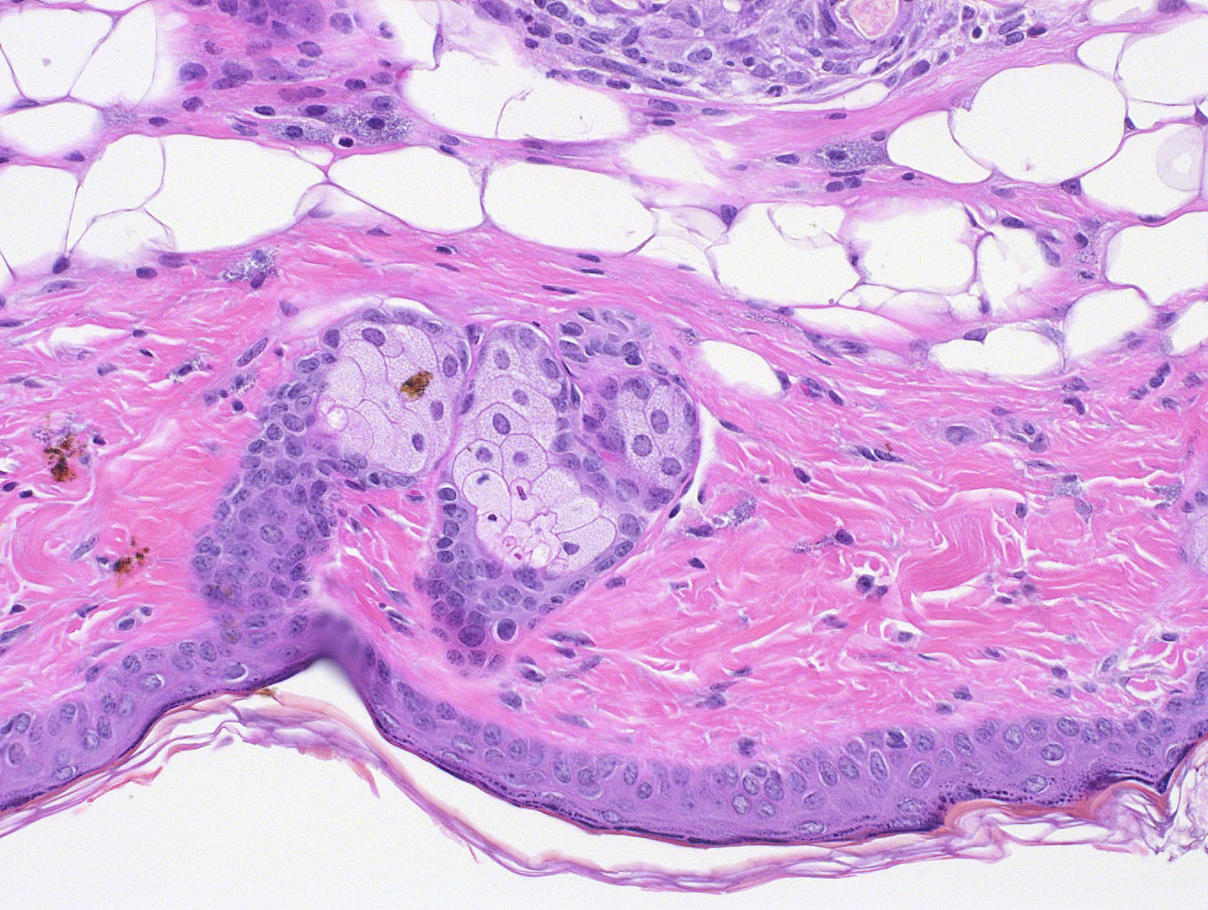

Mouse # 122

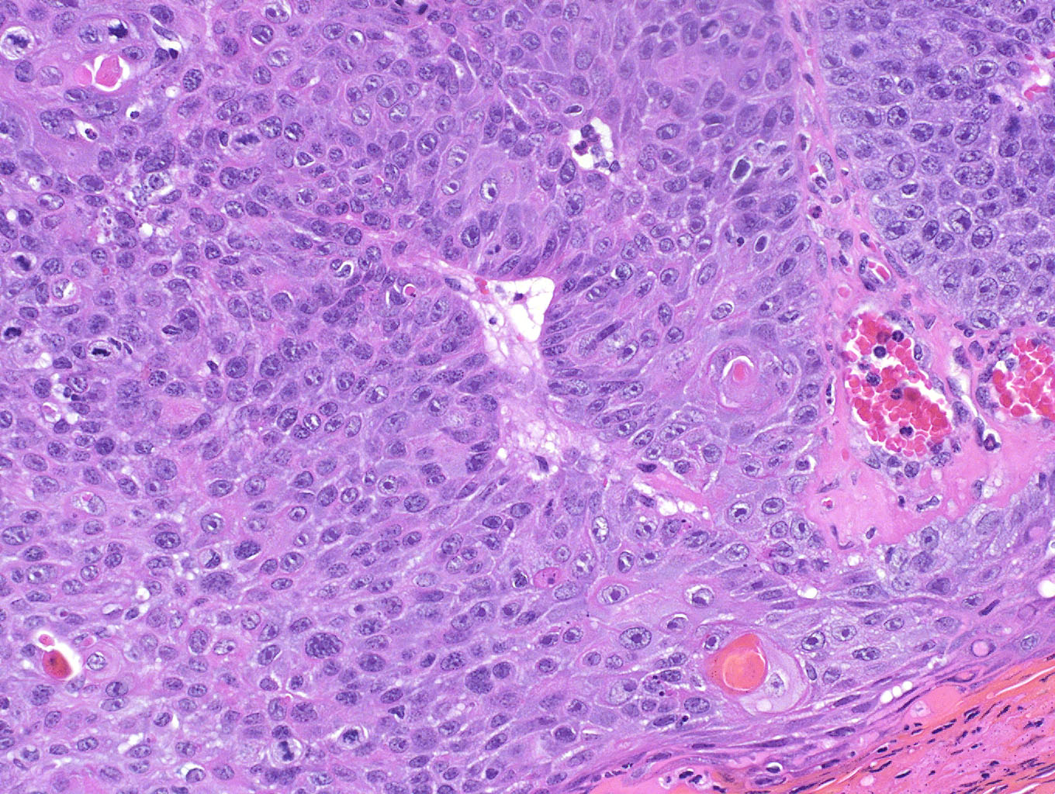

Mouse # 131

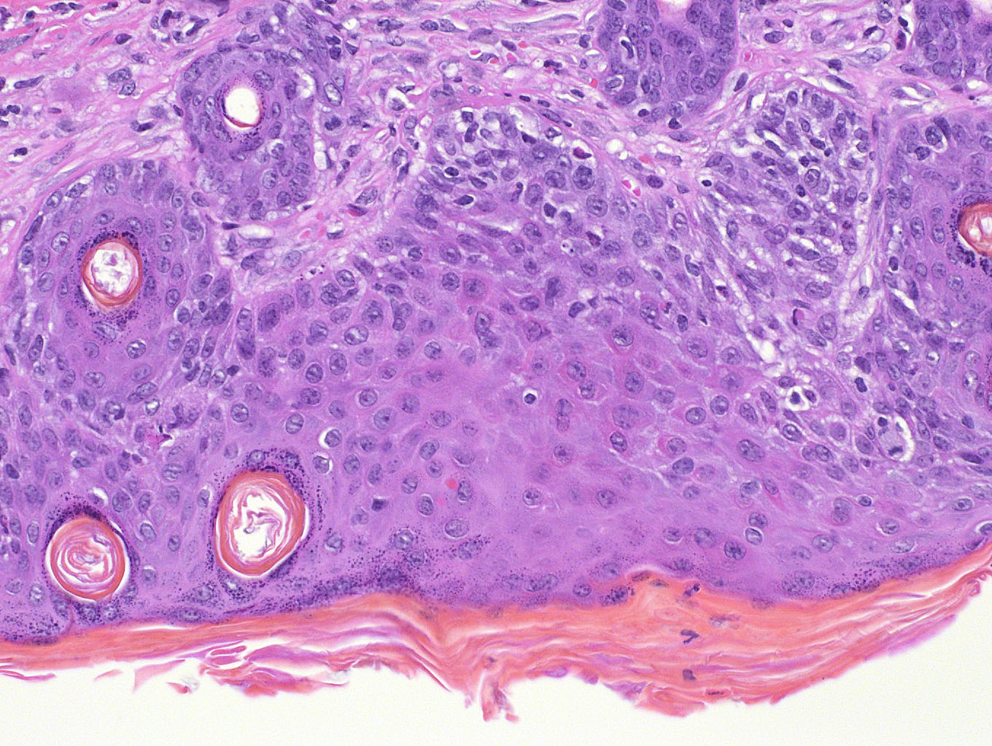

Mouse # 164

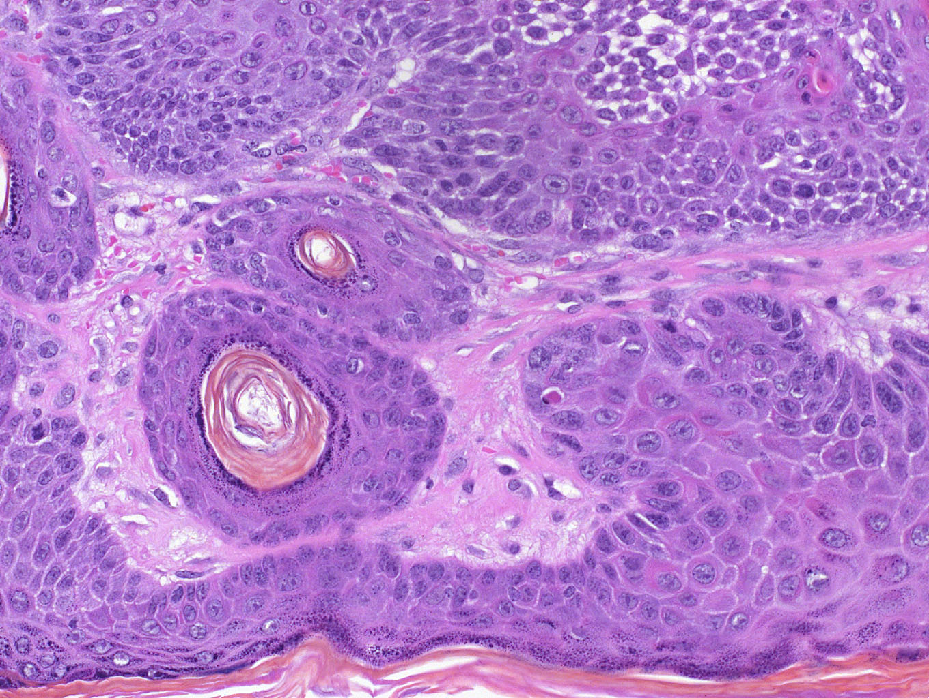

Mouse # 226